**Object Oriented Programing Project Report**

<use appropriate image as per your project>

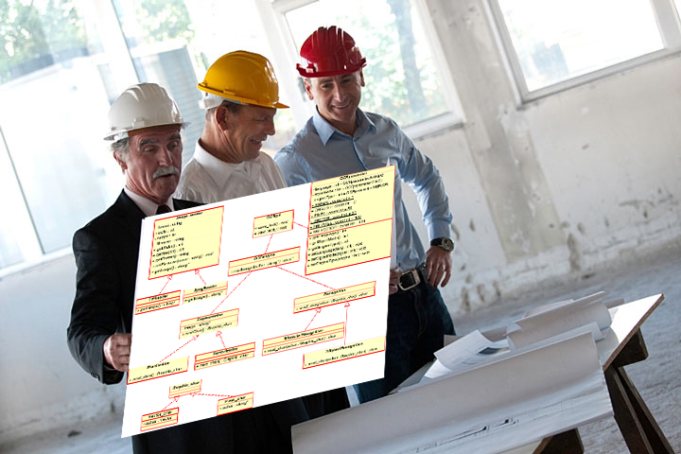

**Grocery Store Inventory Management System**

**Prepared by**

**Santiago Lopez  
Ehsan Arehpanahi**

**Jason Zabawskyj**

**Shah Ahmed**

**at the**

**Seneca College**

**November 2023**

**Table of Contents**

Contributions 3

I Presentation YouTube link 3

II Project Description 3

1 Project Overview 3

2 The Purpose of the Project 3

2a The User Business or Background of the Project Effort 3

3 The Scope of the Work 4

III Requirements 4

4 Product Use Cases 4

IV Design 4

5 UML Class Diagram 4

V Testing and Evaluation 4

6 Features to be tested. 4

7 Pass/Fail Criteria 4

VI Project Issues 4

8 Lessons Learnt 4

VII Conclusion 4

VIII References 4

### ****Contributions****

|  |  |  |  |  |
| --- | --- | --- | --- | --- |
| **Student ID** | **Name** | **Components** | **Details** | **Development hours** |
|  |  |  |  |  |
|  |  |  |  |  |
|  |  |  |  |  |
|  |  |  |  |  |

# Presentation YouTube link

# Project Description

## Project Overview

The program allows staff members to update and navigate through the different categories of inventory in the store.

## The Purpose of the Project

### The User Business or Background of the Project Effort

Content

The content of the program consists of all the different categories inside the inventory, which can be updated by the store’s employees. The multiple categories consist of Fruit, Vegetables, Meat, Dairy, Bakery, Frozen, Deli, Beverages, Personal Care, and Cleaning.

The store receives and sells different products from the different categories listed in the program. When receiving new products, staff members would use the program to enter them into the system and update their inventory.

Motivation

The program is designed to create a user-friendly system that allows users to manage their inventory by adding and removing product data.

Considerations

Issues in the program need to be taken into consideration at the moment users are updating the inventory. Different options are available for users to add a product, delete a product, or update an entire category.

## The Scope of the Work

The program is designed to manage and display information about various categories of products in a grocery store. It allows users to add products to different categories and then view the products within a selected category.

Program Components:

* Product Class represents a generic product in the store.
* Contains common attributes such as name, price, and quantity. Provides a method to display product information.

Category Class:

* Serves as a base class for specific product categories (e.g., FruitCategory, VegetableCategory).
* Manages a vector of products specific to its category.
* Provides methods to add products to the category and display products within the category.

Specific Category Classes:

* Derived from the Category base class (e.g., FruitCategory, VegetableCategory).
* May include additional functionality or cleanup specific to each category.

DisplayManager Class:

* Manages instances of different category classes (e.g., FruitCategory, VegetableCategory).
* Provides methods to add products to specific categories (addProductToCategory) and display products within a selected category (displayProductsInCategory).

Main Function:

* Demonstrates the usage of the program.
* Creates an instance of the DisplayManager class.
* Adds products to different categories using addProductToCategory.
* Displays products within a selected category using displayProductsInCategory.
* Product Addition: The program allows users to add products to specific categories, such as fruits, vegetables, etc.
* The addProductToCategory method is used to add a product to a particular category.

Product Display:

* Users can choose a category, and the program displays the products within that category.
* The displayProductsInCategory method is responsible for this functionality.
* Memory Cleanup: The program takes care of memory cleanup by deleting product instances when a category or the entire program is terminated.
* This is done in the destructor of the Category class and, consequently, in derived classes.

Limitations and Potential Enhancements:

* The program currently supports a limited set of categories (e.g., fruits, vegetables).

# Requirements

## Product Use Cases

1. Creation of a Product:

* Use Case: A new product is added to the inventory.
* The Product class provides a constructor that initializes the name, price, and quantity of the product.
* Users or other parts of the program can create instances of the Product class by providing the necessary information.

2. Displaying Product Information:

* Use Case: Users want to view details of a specific product
* The Product class includes a display method that prints the name, price, and quantity of the product to the console.
* This allows users to easily inspect the information associated with a particular product.

3. Retrieving Product Name:

* Use Case: Users need to identify a product by its name.
* The Product class includes a getName method that returns the name of the product.
* This allows users or other parts of the program to retrieve and display the name of a product without directly accessing its attributes.

4. Calculating Total Price:

* Use Case: Users want to calculate the total value of a quantity of a specific product.
* The Product class provides a calculateTotal method that computes and returns the total price of the product based on its price and quantity.
* This can be useful for tasks such as generating invoices or tracking the overall value of the inventory.

## UML Class Diagram

# Testing and Evaluation

## Features to be tested.

## Pass/Fail Criteria

# Project Issues

## Lessons Learnt

# Conclusion

Write the conclusion of the project by discussing the issues, solutions and the outcome.

# References

This section describes the documents and other sources from which information was gathered. This sample bibliography was generated using the “Insert Citation” and “Bibliography” buttons in the “Citations & Bibliography” section under the “References” tab of MS Word. Creating new citations will not update this list unless you click on it and select “Update Field”. You may need to reset the style for this paragraph to “normal” after updating.

|  |  |
| --- | --- |
| [1] | Robertson and Robertson, Mastering the Requirements Process. |
| [2] | A. Silberschatz, P. B. Galvin and G. Gagne, Operating System Concepts, Ninth ed., Wiley, 2013. |
| [3] | J. Bell, "Underwater Archaeological Survey Report Template: A Sample Document for Generating Consistent Professional Reports," Underwater Archaeological Society of Chicago, Chicago, 2012. |
| [4] | M. Fowler, UML Distilled, Third Edition, Boston: Pearson Education, 2004. |